

Centre number | 9 | 8 | 9 | 6 | 9 | Candidate number | 0 | 2 | 2 | 6
Surname | Deal
Forename(s) | James
Candidate signature
Programming Language | Python (7517/1D)

A-LEVEL COMPUTER SCIENCE
Paper 1

Monday 11 June 2018
Morning
Time allowed: 2 hours 30 minutes

Instructions
- This is the Electronic Answer Document (EAD). Answer all questions by entering your answers into this document on screen. You must save this document at regular intervals.
- Before the examination begins, type the information needed in the boxes at the top of this page.
- Before the examination begins, type the information needed in the boxes in the footers (page 2 onwards) of this EAD.

During the examination
- You may print pages of your EAD. A print monitor will collect and deliver your print-out to you. You must not collect your own print-out.

Exceptions
- If you experience difficulty inserting screen shots into your EAD then you may print these separately and attach them to the back of the EAD with a reference in the correct place in the EAD. Ensure that your Centre Number, Candidate Name and Candidate Number are on each sheet.

At the end of the examination
- Save for the last time and print your EAD on one side only (not double-sided). A print monitor will collect and deliver your print-out to you. Check that your details are in the footers of every page. Write them in if they are not.
- Enter your signature on the front cover.
- Staple or tie all pages together in the top left-hand corner of the EAD.
- Hand in all pages of the EAD to the Invigilator.

Warning
- No extra time is allowed for printing and collating.
- It may not be possible to credit an answer if your:
– details are not printed on every page as instructed above
– screen captures are not legible to the Examiner.
Answer all questions.
You must save this document at regular intervals or you may lose your work.

Section A
 |  |  |  |  |  | Leave blank
Question 01
0 | 1 | . | 1 | Take one from the box labelled “onions & carrots”, whatever vegetable is taken out, take that label from the other box labeled with that and swap them around. Then the boxes labels which we took the label from and the box which we have’t considered yet should be swapped around. Now we know what each box actually contains and they are all labelled correctly. |  | 2
 |  |  |  |  |  | 2
 |  |  |  |  |  | 2

 |  |  |  |  |  | Leave blank
Question 02
0 | 2 | . | 1 | 53- |  | 1
0 | 2 | . | 2 | 342*+1- |  | 2
0 | 2 | . | 3 | RPN is often used as it’s simpler for a computer to evaluate and it removes the need for brackets. |  | 2
0 | 2 | . | 4 | A stack can be used for evaluating RPN expressions by taking any operands and pushing them into the stack. Then when we reach an operator, we pop the top two operands from the stack and apply the operation to them with the first popped item on the right of the equation and second popped item on the left. The result is pushed back onto the stack and this continues with every operator until there is only one value in the stack, which is popped out and is the final evaluation. |  | 3  2
0 | 2 | . | 5 | A stack frame can store return address and local variable states. |  | 3  2
 |  |  |  |  |  | 10
 |  |  |  |  |  | 10

 |  |  |  |  |  | Leave blank
Question 03
0 | 3 | . | 1 |  |  | 2
  0 | 2 | 5 | 3 | 0 | 8
  2 | 0 | 1 | 0 | 0 | 0
  5 | 1 | 0 | 0 | 0 | 4
  3 | 0 | 0 | 0 | 1 | 0
  0 | 0 | 0 | 1 | 0 | 5
  8 | 0 | 4 | 0 | 5 | 0
0 | 3 | . | 2 | An adjancey list is more apropriate when the graph’s edges are rarely changed and is more sparce as it is more memory efficient than a matrix. |  | 1/2
0 | 3 | . | 3 | It is not a tree as it has a cycle. |  | 1
0 | 3 | . | 4 | A weighted graph has numerical values on it’s edges to represent distance, cost, etc |  | 1
0 | 3 | . | 5 |  |  | 5/7
  2 |  | 2 |  |  |  |  |  | 1
  5 |  |  | 5 |  |  |  |  |  | 1
  3 |  |  |  | 3 |  |  |  |  |  | 1
  8 |  |  |  |  | 8 |  |  |  |  |  | 1
  3 |  |  | 3 |  |  |  |  |  | 2
  7 |  |  |  |  |  | 7 |  |  |  |  |  | 3
  3 - 4 |  |  |  |  | 3 -  4 |  |  |  |  |  | 4
  8 -
  9
0 | 3 | . | 6 | D[6] is 7 which is the shortest path from node 1 to node 6. |  | 1
0 | 3 | . | 7 | Records the path taken to achieve this path, I.e the order of the nodes visited. |  | 1/2
 |  |  |  |  |  | 12
 |  |  |  |  |  | 16

 |  |  |  |  |  | Leave blank
Question 04
0 | 4 | . | 1 | The halting problem is wether a computer can determine whether a program will halt or not halt based only on it’s inputs but without running the program. |  | 2
0 | 4 | . | 2 | As it is a a non-computable problem |  | 1
0 | 4 | . | 3 | A read/write head, motor to move the tape second is incorrect - a set of transisition rules |  | ½  ½  1
0 | 4 | . | 4 | A universal turing machine is one which can simulate the inputs and outputs of another simulated turing machine within itself. UTM acts as an interpreter. |  | ½  ½  1
0 | 4 | . | 5 | As a universal turing machine is said to have an infite tape and therefore infinite memory which a computer that you can purchase does not. |  | ½  ½  1
 |  |  |  |  |  | 6
 |  |  |  |  |  | 8

Section B

 |  |  |  |  |  | Leave blank
Question 05
0 | 5 | . | 1 | 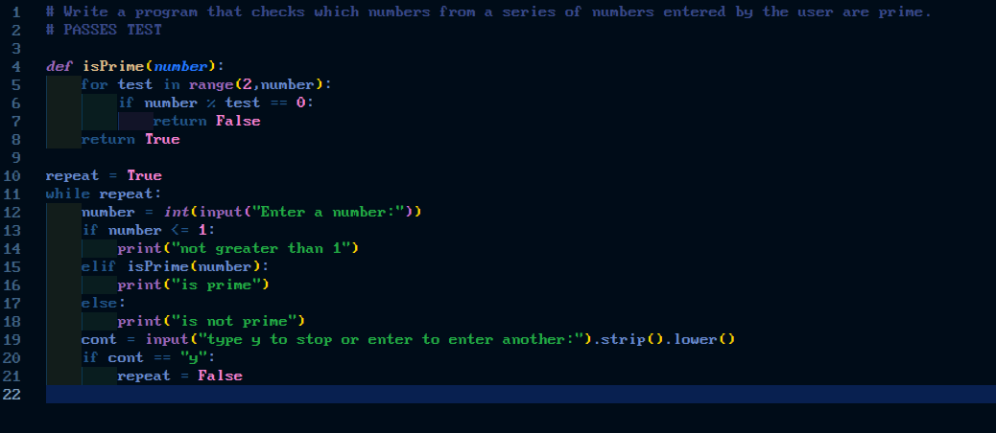
0 | 5 | . | 2 | 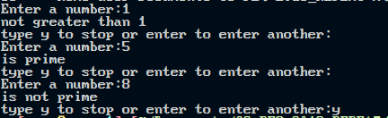
 |  |  |  |  |  | 13
 |  |  |  |  |  | 13

Section C

 |  |  |  |  |  | Leave blank
Question 06
0 | 6 | . | 1 | len() |  | 1
0 | 6 | . | 2 | Item |  | 1  ½  0/1  1  1/4  4/4
0 | 6 | . | 3 | A circular queue is beneficial as it allows the end pointer to be moved over the ends of the queue in memory when items are and moved across to expand when enqued. This reduces the wasted space and makes it more memory efficient. Why? And comparison to linear? e.g)  With a linear queue there could be locations avaliable that are not able to be used as they are before other data items in the queue. To solve this, linear queues shuffle items forward when an item is dequeued from the front. This however leads to time inefficiency.  Therefore circular queue is stronger as:  No need to shuffle items forward after dequeing an item in a circular queue; this makes ciruclar queues more time efficient when deleting as the start/end pointer can wrap around the ends. |  | 1  ½  0/1  1  1/4  4/4
0 | 6 | . | 4 | Linear queues can be useful when the number of items is fixed which it is in the case of the skeleton program’s tile queue. A linear queue is unrelated to static and dynamic data structures. This point is not valid. Instead can mention the following as strengths of linear queues:  - The time inefficiency caused by using a linear queue is not substanitial in the skeleton program as it’s only a small number of items. |  | 1  ½  0/1  1  1/4  4/4
0 | 6 | . | 5 | FrontPointer |  | 1  ½  0/1  1  1/4  4/4
0 | 6 | . | 6 | An if else statement could be added in the CreateTileDictionary function. Before this a random choice between a list with the values [True, False] should be made with random.choice() and the first if statement should check if the random.choice was True, if it was this should lead to only the first if statement for tiles worth 1 being run, while if the statement is False it should lead to the else which runs the remaining three if statements. Therefore there should be a 50/50 chance of a 1 point tile and a tile worth more than 1 point.  Looking at wrong function, should be the Add() method not this function. If the choice is True, it should then generate a random number from those equivalent to generating a 1 point tile. If the generation is False, it should geenerate a random number from those equivalent to more than 1 point tiles. |  | 1  ½  0/1  1  1/4  4/4
0 | 6 | . | 7 | This lower to uppercase conversion could be achieved using a pre-defined dictionary of lowercase allphabetical characters as a key and upercase alphabetical characters as a value. Prior to the loop an empty string for storing the output string should be defined. Then a for loop could iterate through the users input string and enter each character into the dictionary. This would return the uppercase equivalent which is added to the output string This repeats until we reach the end of the for loop and after the loop we return the output string. |  | 1  ½  0/1  1  1/4  4/4
 |  |  |  |  |  | 9
 |  |  |  |  |  | 14

Section D

 |  |  |  |  |  | Leave blank
Question 07
0 | 7 | . | 1
0 | 7 | . | 2
 |  |  |  |  |  | 2

 |  |  |  |  |  | Leave blank
Question 08
0 | 8 | . | 1
0 | 8 | . | 2
 |  |  |  |  |  | 5

 |  |  |  |  |  | Leave blank
Question 09
0 | 9 | . | 1
0 | 9 | . | 2
 |  |  |  |  |  | 9

 |  |  |  |  |  | Leave blank
Question 10
1 | 0 | . | 1
1 | 0 | . | 2
 |  |  |  |  |  | 9

 |  |  |  |  |  | Leave blank
Question 11
1 | 1 | . | 1
1 | 1 | . | 2
 |  |  |  |  |  | 12

If you have made any separate screen captures, put a reference in the correct place in this Electronic Answer Document.

Ensure that your Centre Number, Candidate Name and Candidate Number are on each sheet.

Attach them to the back of this document.

NB: The AQA logo is provided for use only in the Electronic Answer Document for the 2018 A-level Computer Science Paper 1 (7517/1) examination and must not be used for any other purpose.

Copyright © 2018 AQA and its licensors. All rights reserved.

